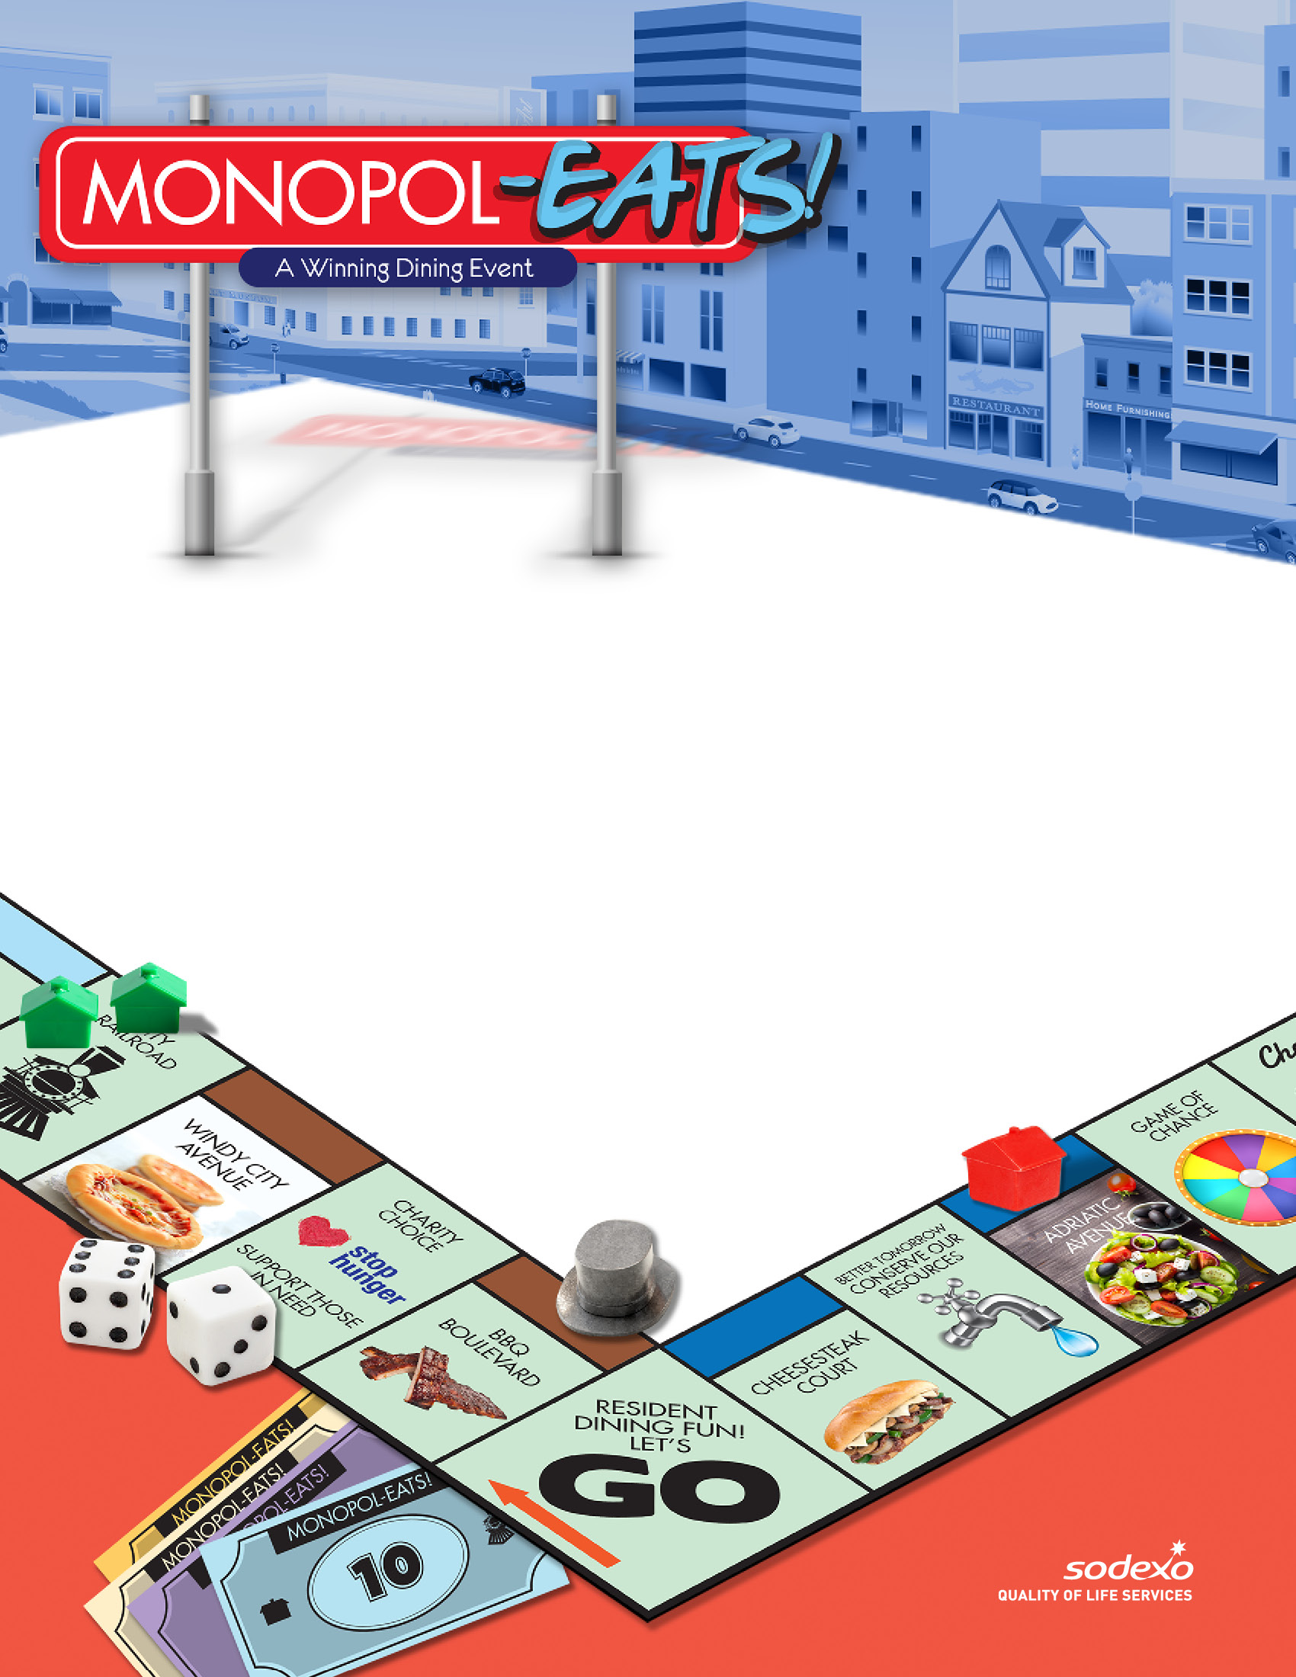

**CONGRATULATIONS  
TO OUR WINNER!**

**(Insert Winner’s Name)**  
(Insert Winner’s School Name, City, State)   
(Insert Winner’s First Name)   
received (insert text).