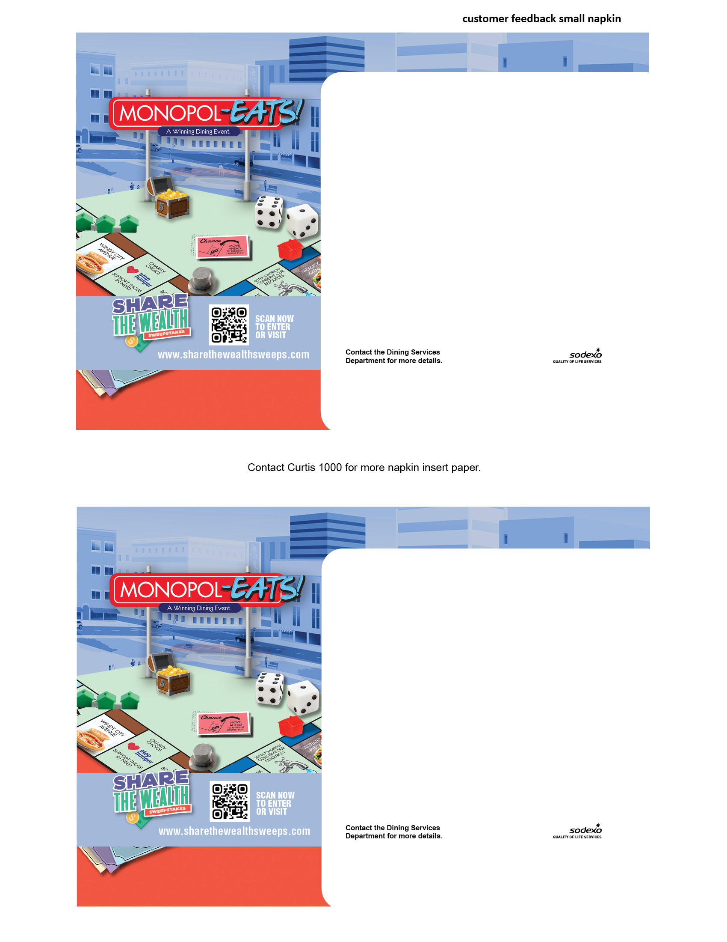

WE WANT TO HEAR FROM   
YOU SO WE CAN MAKE OUR NEXT   
PROMOTION EVEN BETTER!

**WE WANT TO HEAR FROM   
YOU SO WE CAN MAKE OUR NEXT   
PROMOTION EVEN BETTER!**

Do you like the **Monopol-EATS!** promotion?   
If so, what has been your favorite part? In what ways   
can we improve next time? Let us know what   
you think by [INSERT HOW YOU ARE GAUGING STUDENT SATISFACTION WITH YOUR EVENT/  
INSTRUCTIONS FOR LEAVING FEEDBACK].

**We appreciate your help!**

Do you like the **Monopol-EATS!** promotion?   
If so, what has been your favorite part? In what ways   
can we improve next time? Let us know what   
you think by [INSERT HOW YOU ARE GAUGING STUDENT SATISFACTION WITH YOUR EVENT/  
INSTRUCTIONS FOR LEAVING FEEDBACK].

**We appreciate your help!**

Please delete dotted lines before printing