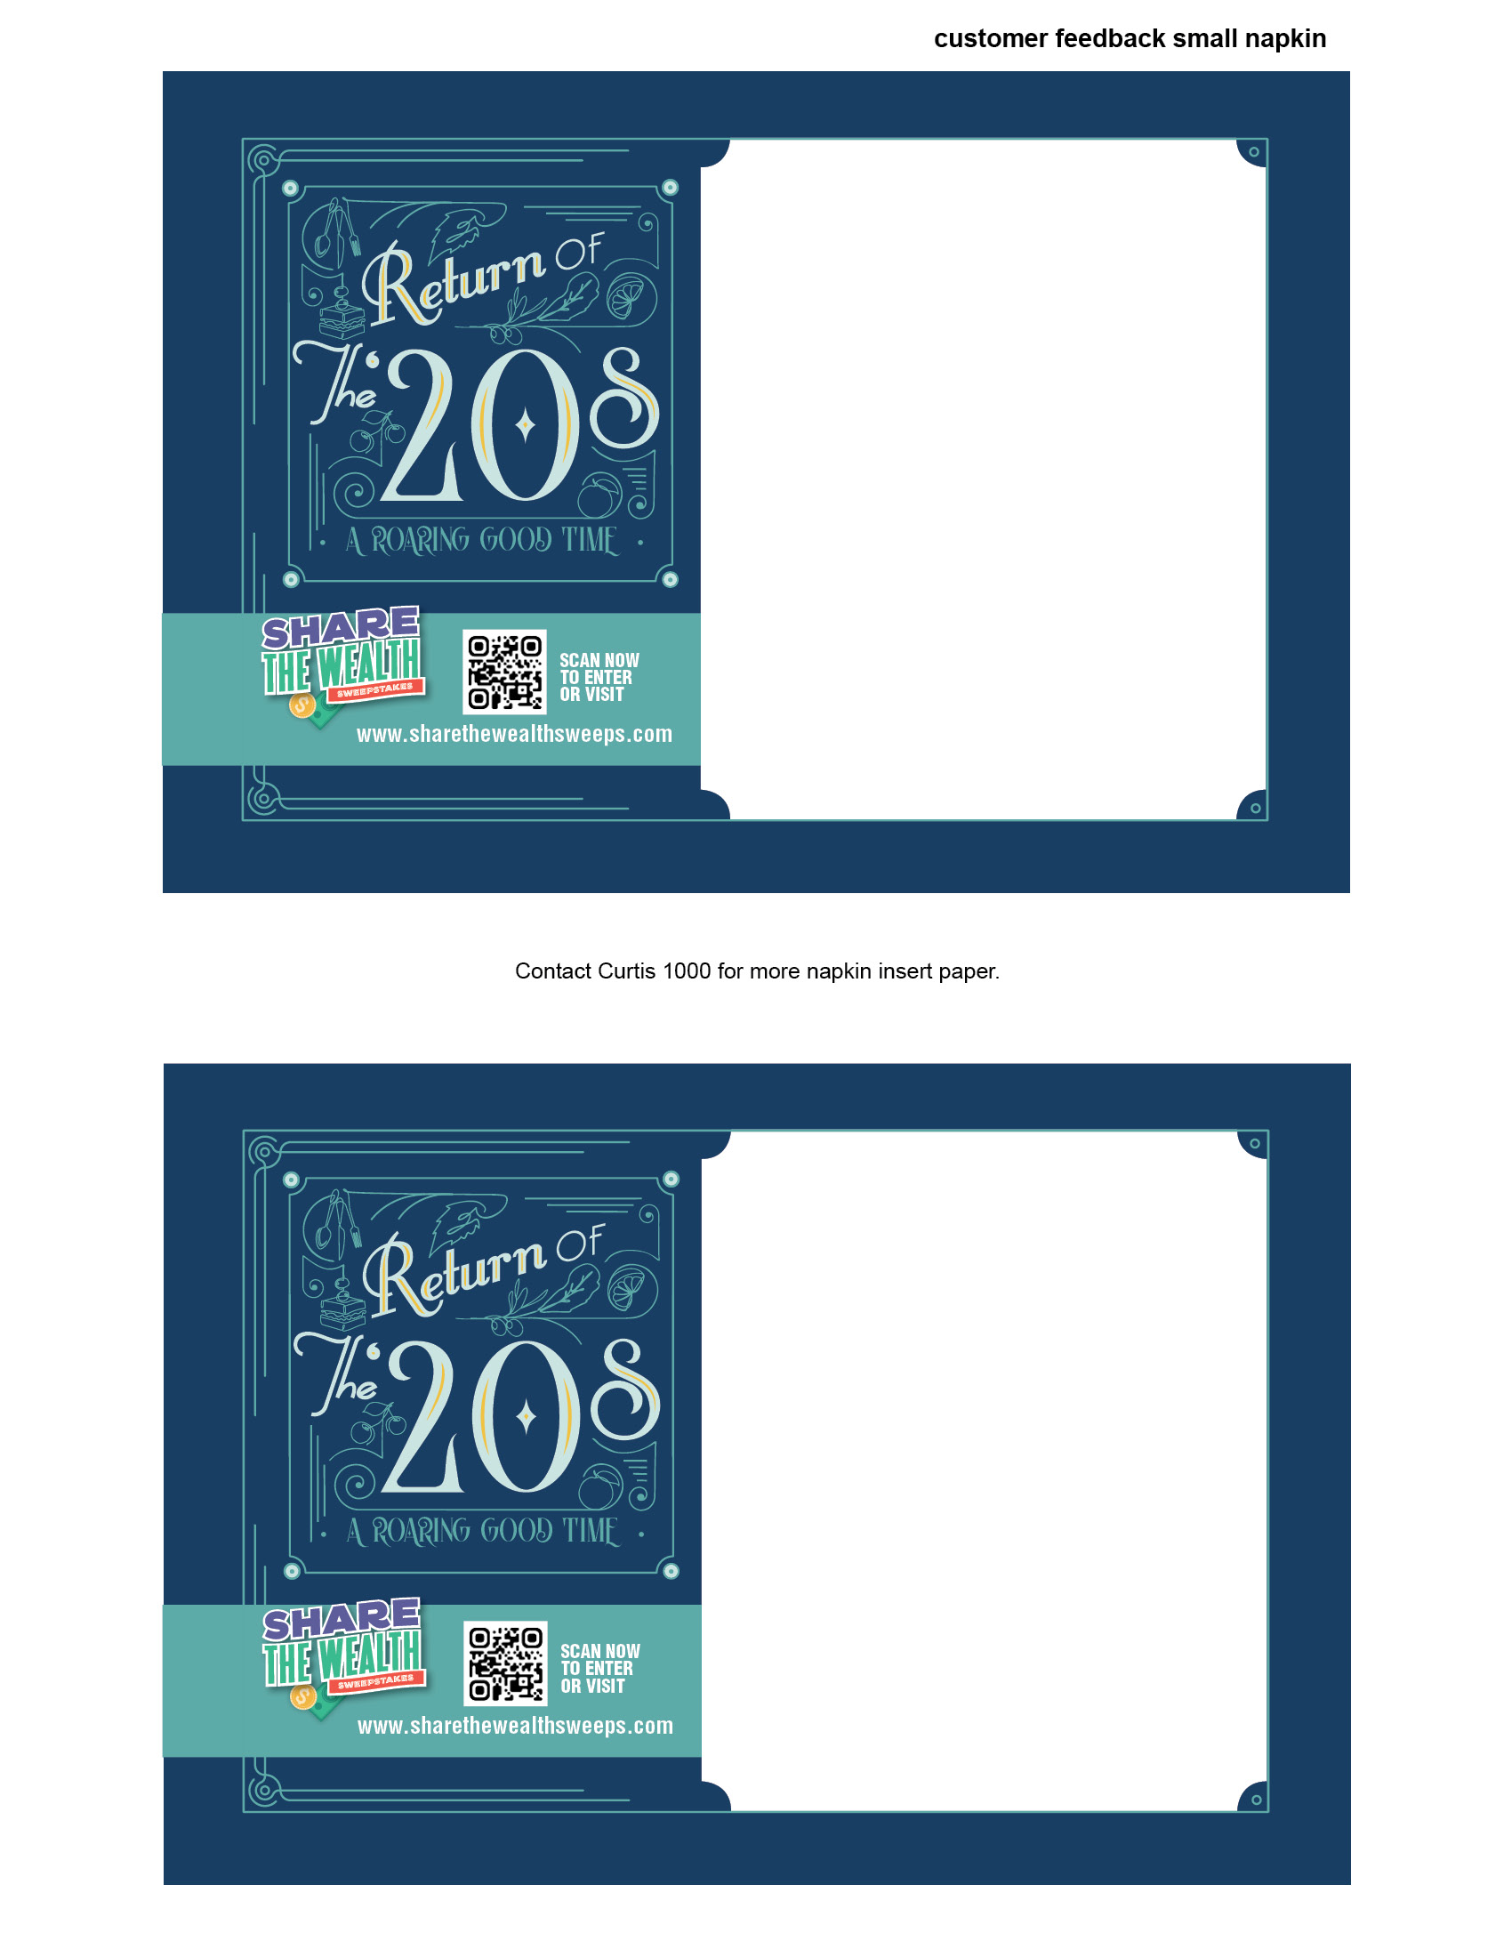

WE WANT TO HEAR FROM YOU   
SO WE CAN MAKE OUR NEXT PROMOTION EVEN BETTER!

Do you like the **Return of the 2’0s** promotion?   
If so, what was your favorite part? In what ways   
can we improve next time? Let us know what   
you think by [INSERT HOW YOU ARE GAUGING STUDENT SATISFACTION WITH YOUR EVENT/  
INSTRUCTIONS FOR LEAVING FEEDBACK].

**We appreciate you help!**

Do you like the **Return of the ‘20s** promotion?   
If so, what was your favorite part? In what ways   
can we improve next time? Let us know what   
you think by [INSERT HOW YOU ARE GAUGING STUDENT SATISFACTION WITH YOUR EVENT/  
INSTRUCTIONS FOR LEAVING FEEDBACK].

**We appreciate you help!**

**WE WANT TO HEAR FROM YOU   
SO WE CAN MAKE OUR NEXT PROMOTION EVEN BETTER!**

**Contact the Dining Services Department for more details.**

**Contact the Dining Services Department for more details.**

Please delete dotted lines before printing